Chicagoland Black Deaf Advocates

Presents
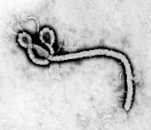
What do you know about EBOLA?
Presentation by Dr. David Edbert
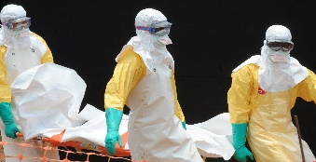

March 21st, 2015

1pm-4pm

Whitney M. Young Magnet High School

Main Building
211 S. Laflin St
Chicago, IL 60607

This event is to better inform and understand about Ebola. There will be a discussion as well as question and answer session.
All are Welcome. The Event is free.

If you have questions or concerns, please do contact us at: www.clbda.weebly.com

